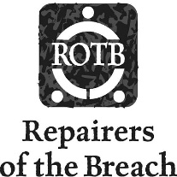
Repairers of the Breach
1335 W Vliet St
Milwaukee, WI 53205
414-934-9305
Repairers.org

Thank you for your donation!

Date: Enter date
Name: Type name here
Address: Type address here
City/State/Zip: Type address here
Email address: Type email here

☐Yes, I would like an acknowledgment letter for my donation
☐No, I do not need an acknowledgment letter for my donation

☐Yes, this donation is for a specific program only: Choose an item.
☐No, this donation can be used for any program

Donated Items: Estimated Value: (resale, not original price)
(optional)
1. Enter item(s) 1. Enter amount
2. Enter item(s) 2. Enter amount
3. Enter item(s) 3. Enter amount
4. Enter item(s) 4. Enter amount
5. Enter item(s) 5. Enter amount
6. Enter item(s) 6. Enter amount
7. Enter item(s) 7. Enter amount
8. Enter item(s) 8. Enter amount
9. Enter item(s) 9. Enter amount

Repairers of the Breach EIN: 39-1707495

